Hybrid (Sandwich) Integration Testing

📖 Definition
# Source: AI Source: Provided by: [Data Path: Persons Table -> ID Column: 1, Name_En Column: Motasem Essam] -> From: [ChatGPT] on [8/23/2025]
Hybrid (Sandwich) Integration Testing is an approach that combines both Top-down and Bottom-up integration testing. Testing is done from the top and bottom simultaneously, and the process meets in the middle.
That’s why it’s called “sandwich” – you test from the “top bun” and the “bottom bun” towards the “filling” in the middle.

🔹 Characteristics
# Source: AI Source: Provided by: [Data Path: Persons Table -> ID Column: 1, Name_En Column: Motasem Essam] -> From: [ChatGPT] on [8/23/2025]
- Starts testing top-level modules (using stubs) and bottom-level modules (using drivers) at the same time.
- Middle modules are integrated last.
- Good balance between early prototype availability (from top-down) and early validation of low-level utilities (from bottom-up).
- More complex to plan and manage compared to pure top-down or bottom-up.

🔹 Objectives
# Source: AI Source: Provided by: [Data Path: Persons Table -> ID Column: 1, Name_En Column: Motasem Essam] -> From: [ChatGPT] on [8/23/2025]
- Validate critical high-level logic early.
- Validate core low-level functions early.
- Reduce the disadvantages of using only one approach.

🔹 Example (ATM System)
# Source: AI Source: Provided by: [Data Path: Persons Table -> ID Column: 1, Name_En Column: Motasem Essam] -> From: [ChatGPT] on [8/23/2025]
Modules:
- A (Top) = User Interface
- B = Account Management
- C = Transaction Processing
- D = Balance Inquiry
- E = Withdrawal
- F = Deposit
🔹 In Hybrid approach:
- Top-down: Start testing A → B using stubs for lower modules (C, D, E, F).
- Bottom-up: Start testing D, E, F (low-level modules) with drivers.
- Eventually integrate everything into C (middle module), where both streams meet.

🔹 Advantages
# Source: AI Source: Provided by: [Data Path: Persons Table -> ID Column: 1, Name_En Column: Motasem Essam] -> From: [ChatGPT] on [8/23/2025]
- Covers both sides: top-level control and bottom-level services tested early.
- Prototype available earlier than Bottom-up.
- Low-level defects are also caught earlier than Top-down.
- Balanced approach for large, complex systems.

🔹 Disadvantages
# Source: AI Source: Provided by: [Data Path: Persons Table -> ID Column: 1, Name_En Column: Motasem Essam] -> From: [ChatGPT] on [8/23/2025]
- More complex to plan and manage.
- Requires both stubs and drivers.
- Middle modules are tested late (integration bottleneck).

⚖️ Comparison of All Integration Approaches
# Source: AI Source: Provided by: [Data Path: Persons Table -> ID Column: 1, Name_En Column: Motasem Essam] -> From: [ChatGPT] on [8/23/2025]
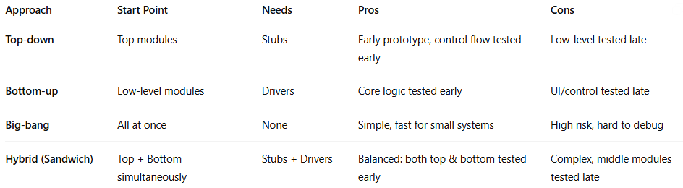
Approach | Start Point | Needs | Pros | Cons
Top-down | Top modules | Stubs | Early prototype, control flow tested early | Low-level tested late
Bottom-up | Low-level modules | Drivers | Core logic tested early | UI/control tested late
Big-bang | All at once | None | Simple, fast for small systems | High risk, hard to debug
Hybrid (Sandwich) | Top + Bottom simultaneously | Stubs + Drivers | Balanced: both top & bottom tested early | Complex, middle modules tested late

✅ In short:
Hybrid (Sandwich) Integration Testing = A mix of Top-down and Bottom-up → test from both ends → meet in the middle. Balanced but complex.

